In the classroom - exercise 1
 | This is a
 | This is a
 | This is a
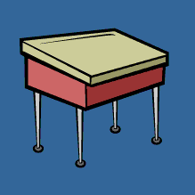 | This is a
 | This is a
 | This is a
 | This is a
 | This is a
 | This is a
 | This is a
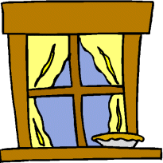 | This is a
 | This is a
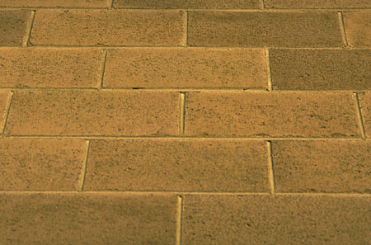 | This is the
 | This is the
 | This is a
 | This is a

