In the classroom - exercise 2
 | This is a
 | This is a
 | This is a
 | This is a
 | This is a
 | This is a
 | This is a
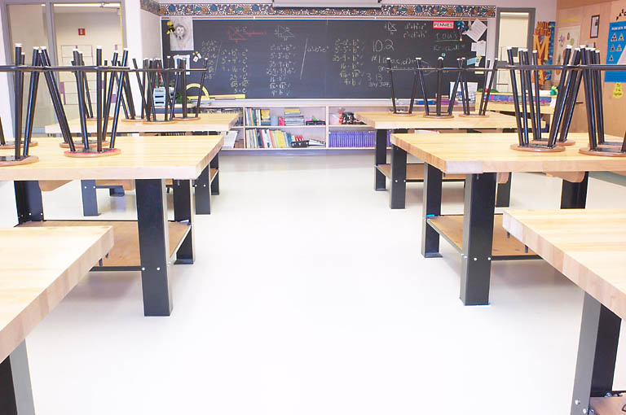 | This is the
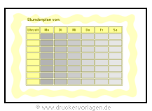 | This is the
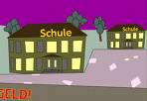 | This is the
 | This is a
Klassenkameraden | These are our
 | This is our

